
Point E(vents)
in Delphi executables
[marciano – 22-august-2007]

Introduction

In the last weeks our companions Lisa&&Alquimista (Arapumk) they delighted us with MiniDE, a decompiler for Delphi executables that is able to obtain addresses of all the events of a program. MiniDE allows us to generate .MAP files that we will be able to import into OllyDbg with plugins like MapConv or GODUP, in order to add comments and/or labels with the names of the events.
If we add the events information in the form of comments and/or labels we will see that it is much more simple to understand the operation of the program, and what matters more is, cracking it is much more comfortable.

In case it was not clear previously this, I will show it with a couple of images. In this screen capture we see the disassembly of a program compiled in Delphi, without the events information added:

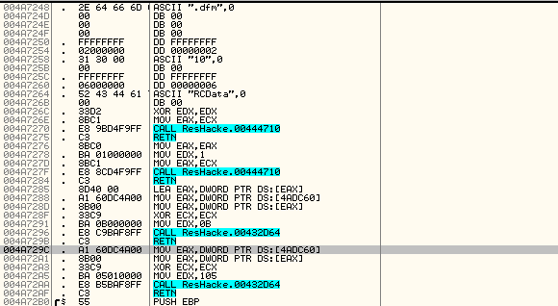

And next, the same program in Delphi, but to that was added the .MAP file generated by MiniDE with the events information:

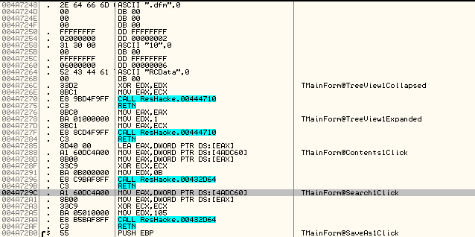

The images speak for themselves. Adding information on events in the form of comments we can reduce the time substantially that it takes to us crack a program compiled with Delphi.

Delphi and events

The tool developed by Arapumk is brilliant and I recommend its use widely, but to learn a little more, we will see how to collect all this info on events “almost” manually.

In order to begin we will make a brief review on events in Delphi applications. In order to internalize itself in the subject it is more fundamental to read tutorial 037-OLLYDBG Y DELPHI por COCO.

In the paradigm of Object-oriented programming (POO), the objects respond to certain actions (events).
In Delphi, all controls (buttons, checkboxes, grids, labels, edits, radio buttons, etc) are an object, and therefore will respond to events.

We see some possible events, eg. for a button:

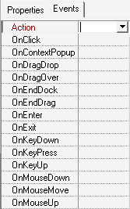

When a click occurs on this button, the OnClick event will be generated; when the mouse moves on this button, the OnMouseMove event is triggered; and so on.

However, Delphi stores that event information in a way that is legible/readable for a human. How is this done? We will see it with an example.
We begin by examining a Delphi executable with Resource Hacker. We go to the node RCData, and then anyone of the Sub-nodes that represent a Form (in this case I am examining, Resource Hacker in Resource Hacker).

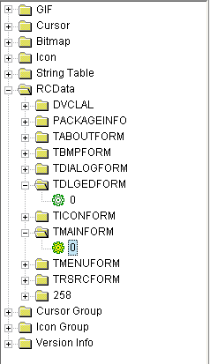

In the panel on the right, we will see the properties of each control that exist on the Form selected (width, height, alignment, title, etcetera), and also, the events information:

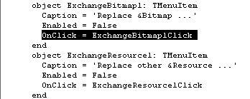

Notice the emphasized line: it says OnClick = ExchangeBitmap1Click.
That line is nothing more than the name of the routine (ExchangeBitmap1Click) that one will go off when becomes it produces Click event on the object ExchangeBitmap1, of type Menu Item.

It is important to emphasize that Delphi executables contain the names of the controls and events that the programmer defined. Knowing this, a technique exists to manually find the address of the routine, where a certain event on the selected object takes place.
(NOTE: For that just they begin, we remember that it is possible to find the addresses of the events by using a tool called DeDe).

Continuing with the analysis of the same executable. Suppose that we wished to find the address of the event ExchangeBitmap1Click. What we will do first of all, will be to load the executable in OllyDbg and go to the beginning of the CODE section.:

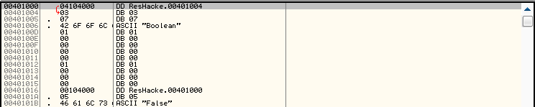

Then we press Ctrl+B in order to do a binary search, and we search for the ASCII string corresponding to the name of the event that is of interest to us:

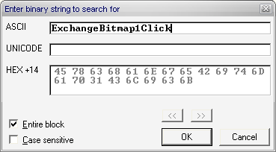

It takes us to the string that we just searched for:

Notice that 5 bytes of the string, are in 0049EC77, we see the data definition
DD 004A6AA4.
That address 004A6AA4 is the address of the event ExchangeBitmap1Click. We go there and we see the code that it will execute when that event takes place:

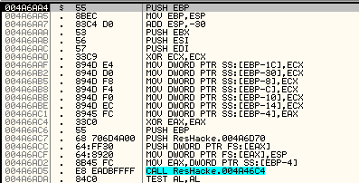

If we placed a breakpoint there, execution pauses when we click on the object ExchangeBitmap1; if we look at the screen capture that we analyzed with ResHacker, the object ExchangeBitmap1 is a Menu Item and it has the title/caption “Replace Bitmap...”.

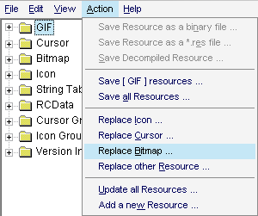

The addresses of the events are stored in the same way, for all the controls existing in the application. We watch this:

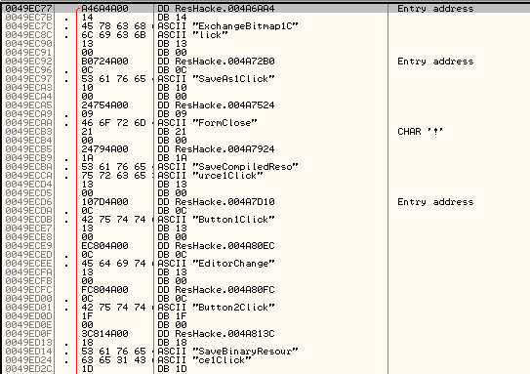

We now know how Delphi stores the address of an event.
Some questions arise to us: Why are the addresses of the events stored? When does a program read that information? What does a program do with the events address information?
Lets find out.
Finding the Point E(vents)

We had said that in the address 0049EC77 we had the data definition DD 004A6AA4, and that it indicated the address of the event ExchangeBitmap1Click.

We want to see at what moment the program reads the data of the event. Without doubts it will have to do it during a stage of initialization, before showing the interface of the program to the user, since the application will have to be prepared to respond to the different events that it can shoot the person that it using the software.
In order to determine this, we select the line with the data definition in 0049EC77 and then we do a right click → Follow in dump → Selection.

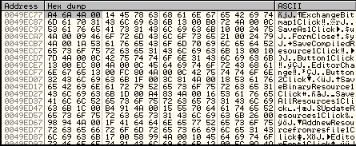

There we see 4 bytes corresponding to the address of the event. Since we want to pause when the program reads that information, we place a hardware breakpoint on access on these 4 bytes and then run with F9.
The execution pauses in our hardware breakpoint:

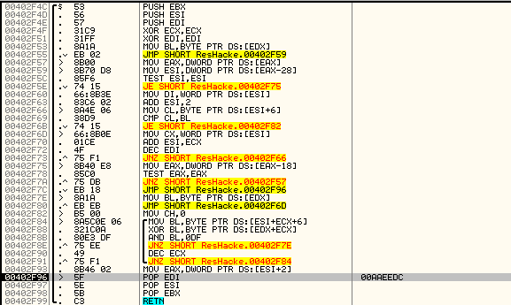

As it happens with hardware breakpoints, we are located in the instruction following to which produced breakpoint.
The previous instruction, that is to say,, MOV EAX, DWORD PTR DS:[ESI+2], was the one that that read the address of the event. In effect, we see in EAX the address 004A6AA4, corresponding to the event ExchangeBitmap1Click:

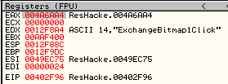

But look at what we also found in EDX! The name of the event in question!
We clarify that in EDX we have the name of the event in the Delphi strings format. The Delphi strings do not finish with the character 0x00, but its length is determined by the value stored in a byte (or dword for long strings) that precedes the string. Pay attention to EDX 14 is the length of the string, “ExchangeBitmap1Click”. That byte has the value 14h that precedes the string and indicates the length of the string (“ExchangeBitmap1Click” has a length of 14h characters).

Nevertheless, if we press F7 twice in order to execute until POP EBX, we see that ESI points to the name of the event, and with the string format that we are used to (string finished with byte 0x00):

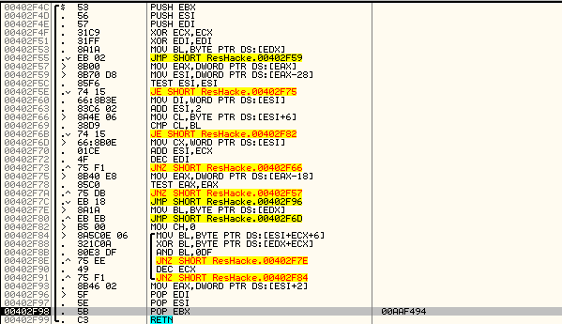

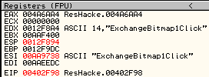

Then, when arriving at POP EBX, we have:

- The name of the event in ESI.
- The address of the event in EAX.

Without doubts this is the part of the initialization code in which it reads the names and addresses of events, it can be very useful. Will all the information of events be read from this same zone of code? Lets find out. We place a breakpoint on the POP EBX that is below MOV EAX, DWORD PTR DS:[ESI+2] and we restart with Ctrl+F2.

Run with F9 and Olly is paused in our breakpoint:

Look at the registers:
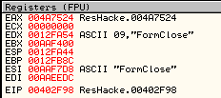

We have in ESI the name of the event (FormClose) and in EAX the address of that event (004A7524).
Press F9 in order to follow and it returns and pauses in our breakpoint:

If we watch the registers, we continue seeing events information:

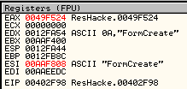

We have in ESI the name of the event (FormCreate) and in EAX the address of that event (0049F524).

If we continue to run the program we will see how one pauses several times more in our breakpoint, and if we watched the registers we will see march past the information of events; ESI always points to the name of the event and EAX always contains the address of that event.

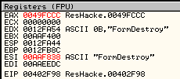

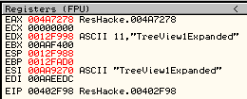

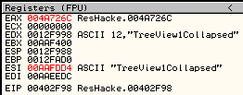

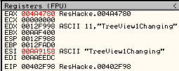

As Arapumk says in the tutorial 243-Punto magico en Delphi por ARAPUMK, all Delphi executables have a routine of initialization that reads the addresses of all the events, and with this data it fills up a table of events, on the basis of which it is going to react before the different carried out actions by the user of the program.

We have finished finding the point in which the events information is read, and we saw that through the registers we can obtain the names and addresses of all the events of the program. To this point I will call it Point E(vents), or simply Point E, to continue with the nomenclature that Ricardo started.

We review then how to locate Point E in an executable compiled with Delphi. The instruction that read the addresses of the events was MOV EAX, DWORD[ESI+2].
To find this instruction quickly, we go to the to the beginning of the Code section and search for it with Ctrl+F:

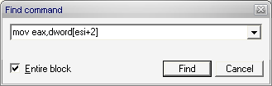

The search will take us straight to the hot zone:

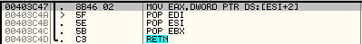

The Point E is exactly in the POP EBX that it is seen below, that is to say, 5 bytes below the instruction MOV EAX, DWORD PTR DS:[ESI+2]. If we placed a breakpoint in the Point E we could be seeing the names and addresses of all the events of the program.

A plugin to work with Point E

Locating the Point E we have all the information of events within reach. For each time we pause at Point E, we could add a comment and/or label at the address EAX the name of the event pointed to by ESI.
But to do this by hand would be too tedious in big programs, where it can have tens and tens of events. The alternative is to automate it: Leaving the hard work for the machine (after all, that is why machines exist).
First idea that came to me, was to write a script that to locate Point E, and on each break it adds at the address of EAX the name of the event pointed to by ESI, as a comment and/or label.

Nevertheless I did not find a way to obtain this by use of a script the text string “limpia” at that it aims ESI when happening through Point E. So I had to resort to programming my first plugin for OllyDbg.

The plugin is called “Point E(vents)”. We must execute it when we were paused on the EntryPoint of a program compiled with Delphi:

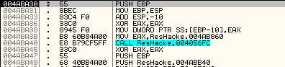

In the plugin`s menu, we choose the option “Find Point E(vents)”:

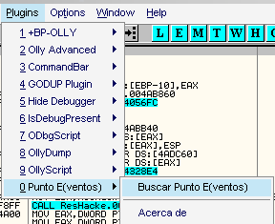

It will show you a MessageBox that tells you the address where it found Point E:

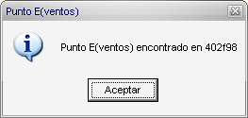

Press OK and another MessageBox will appear:

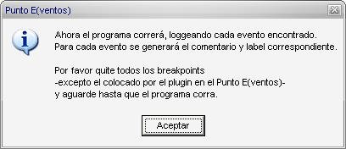

It is telling us that it will run the program and log all the events information. For each event it will generate the a corresponding comment and label.
It will also ask you to remove all breakpoints, except for the one placed by the plugin at Point E. This is not obligatory, but it is recommended to clear the hypothetical ones breakpoints positions by the user, not to have to resume the program manually whenever it pauses in a breakpoint that is not the one in Punto E.
Finally, it will ask the user to wait until the program runs freely. Then the plugin`s task will have finished.

Once the program is running freely, we can view the comments added by the plugin by doing a Search for → User-defined comment.

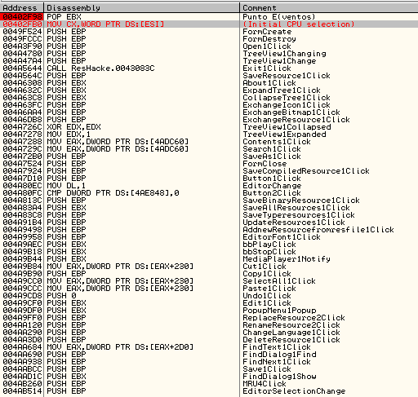

Also, we can see labels inserted by the plugin by doing Search for→ User-defined label.

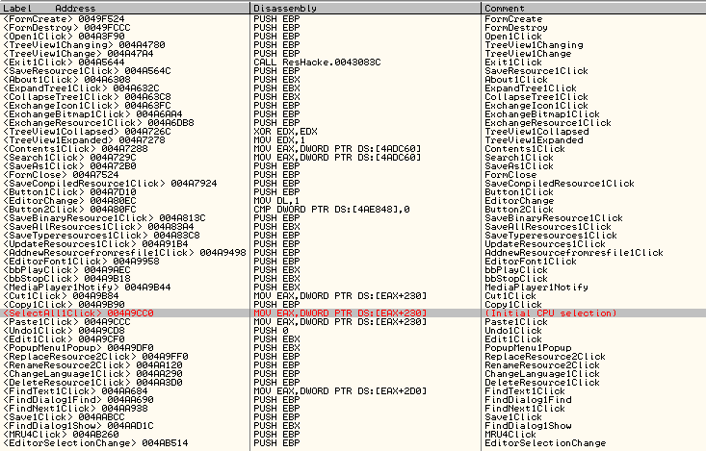
If we look at the code we can see how it is clarified thanks to the insertion of comments with the names of the events:

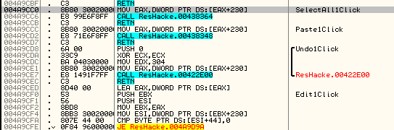

Fin

I hope that the tutorial and plugin are usefull for somebody.
It is also necessary to say that in executables compiled with Borland C++ Builder Punto E also exists, which can also be found, by looking for the instruction MOV EAX, DWORD[ESI+2]. The only difference is that executables compiled with Borland C++, Punto E is sometimes not in first section but more ahead.
A greeting for all the people of the list ☺

[marciano – 22-august-2007]

